YEAR | DESCRIPTION | COST
1 | STREET & ALLEY REPAIRS | $5,300,000
2 | STREET & ALLEY REPAIRS | $5,300,000
3 | STREET & ALLEY REPAIRS | $5,300,000
4 | STREET & ALLEY REPAIRS | $5,300,000
5 | STREET & ALLEY REPAIRS | $5,300,000
 | SUBTOTOAL | $26,500,000
LOCATION | PROJECT | COST
1 | CHELSEA BOULEVARD  (Allen Commerce to SH 121) | $3,550,000
2 | MCDERMOTT DRIVE  (Allen Drive to Greenville Avenue) | $3,830,000
3 | EXCHANGE PARKWAY  (Allen Heights to Angel Pkwy) | $3,760,000
4 | EXCHANGE PARKWAY  (SH121 to Alma Road) | $9,290,000
5 | WATTERS ROAD  (Bethany Drive to SH 121) | $12,640,000
 | SUBTOTOAL | $33,070,000
ITEM | DESCRIPTION | COST
1 | CABINET REPLACEMENT  (26 LOCATIONS) | $715,000
2 | MAIN & FOUNTAINGATE | $330,000
3 | EXCHANGE & BOSSY BOOTS | $400,000
 | SUBTOTOAL | $1,445,000

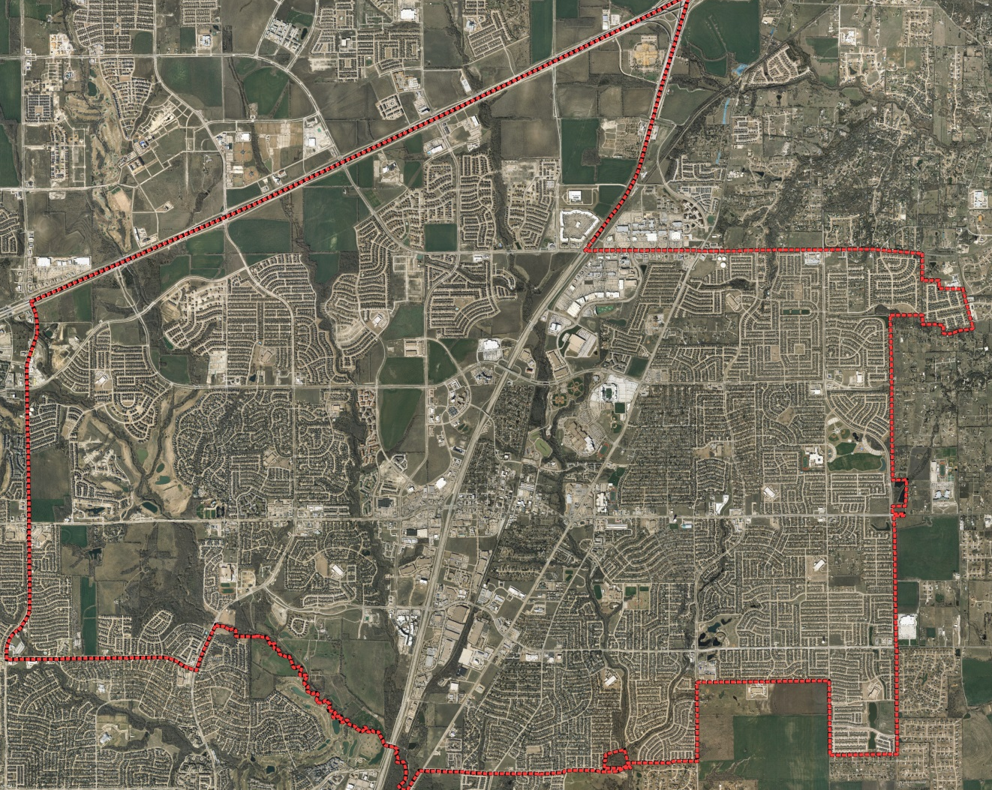
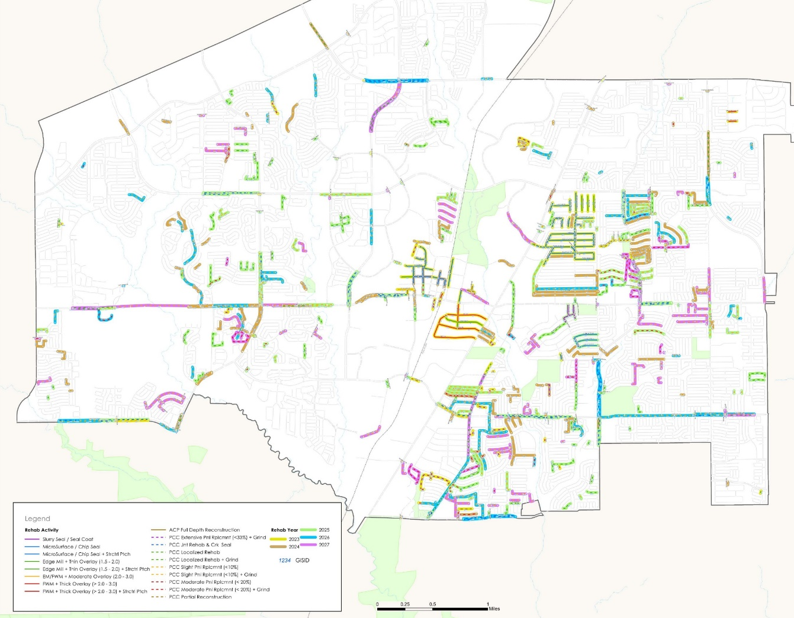
1
4
3
2
CHELSEA
5
US 75
STACY
EXCHANGE
WATTERS
GREENVILLE
SH 121
MAIN
ANGEL
BETHANY
US 75
MCDERMOTT
MCDERMOTT
STACY
US 75
BETHANY
ANGEL
WATTERS
GREENVILLE
MAIN
SH 121
EXCHANGE

